Section A
ERD DIAGRAM 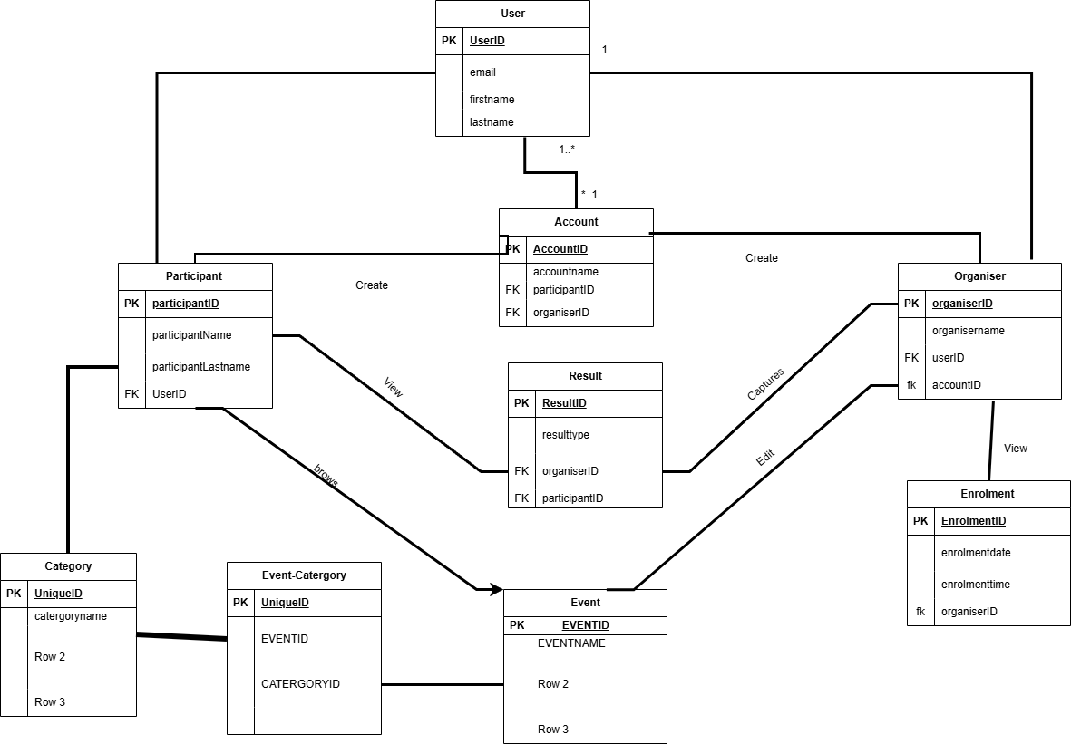
Section B :
HTTP Method | Route | Description | Role Required | Request Body | Expected Response
POST | /api/auth/register | Register new user | None | { "email": "string", "password": "string", "fullName": "string", "role": "organiser|participant" } | 201 Created: { "message": "User registered successfully", "userId": "uuid" }
POST | /api/auth/login | User login | None | { "email": "string", "password": "string" } | 200 OK: { "token": "jwt_token", "user": { "id": "uuid", "email": "string", "role": "string" } }
POST | /api/auth/logout | User logout | User | None | 200 OK: { "message": "Logged out successfully" }
POST | /api/auth/refresh | Refresh access token | User | { "refreshToken": "string" } | 200 OK: { "token": "new_jwt_token" }
HTTP Method | Route | Description | Role Required | Request Body | Expected Response
GET | /api/users | Get all users | Admin | None | 200 OK: { "users": [{ "id": "uuid", "email": "string", "fullName": "string", "role": "string", "createdAt": "datetime" }] }
GET | /api/users/{userId} | Get user by ID | User | None | 200 OK: { "id": "uuid", "email": "string", "fullName": "string", "role": "string", "createdAt": "datetime" }
PUT | /api/users/{userId} | Update user | User | { "fullName": "string", "email": "string", "password": "string" } | 200 OK: { "message": "User updated", "user": { ... } }
DELETE | /api/users/{userId} | Delete user | Admin | None | 204 No Content

GET | /api/accounts | Get all accounts | Admin | None | 200 OK: { "accounts": [{ "id": "uuid", "userId": "uuid", "balance": "decimal", "currency": "string", "status": "string" }] }
GET | /api/accounts/{accountId} | Get account by ID | User | None | 200 OK: { "id": "uuid", "userId": "uuid", "balance": "decimal", "currency": "string", "status": "string", "transactions": [...] }
GET | /api/users/{userId}/account | Get user's account | User | None | 200 OK: { "id": "uuid", "balance": "decimal", "currency": "string", "status": "string" }
POST | /api/accounts | Create account | User | { "userId": "uuid", "currency": "string", "initialBalance": "decimal" } | 201 Created: { "message": "Account created", "accountId": "uuid" }
PUT | /api/accounts/{accountId} | Update account | User | { "status": "active|suspended|closed" } | 200 OK: { "message": "Account updated" }
GET | /api/organisers | Get all organisers | Admin | None | 200 OK: { "organisers": [{ "id": "uuid", "userId": "uuid", "organisationName": "string", "verified": "boolean", "rating": "decimal" }] }
GET | /api/organisers/{organiserId} | Get organiser by ID | User | None | 200 OK: { "id": "uuid", "userId": "uuid", "organisationName": "string", "verified": "boolean", "rating": "decimal", "events": [...] }
POST | /api/organisers | Register as organiser | User | { "userId": "uuid", "organisationName": "string", "description": "string", "contactEmail": "string" } | 201 Created: { "message": "Organiser registered", "organiserId": "uuid" }
PUT | /api/organisers/{organiserId} | Update organiser profile | Organiser | { "organisationName": "string", "description": "string", "contactEmail": "string" } | 200 OK: { "message": "Organiser updated" }
DELETE | /api/organisers/{organiserId} | Delete organiser | Admin | None | 204 No Content

GET | /api/participants | Get all participants | Admin | None | 200 OK: { "participants": [{ "id": "uuid", "userId": "uuid", "skillLevel": "string", "ageGroup": "string", "nationality": "string" }] }
GET | /api/participants/{participantId} | Get participant by ID | User | None | 200 OK: { "id": "uuid", "userId": "uuid", "skillLevel": "string", "ageGroup": "string", "nationality": "string", "enrolments": [...] }
GET | /api/users/{userId}/participant | Get participant profile | User | None | 200 OK: { "id": "uuid", "skillLevel": "string", "ageGroup": "string", "nationality": "string" }
POST | /api/participants | Register as participant | User | { "userId": "uuid", "skillLevel": "beginner|intermediate|advanced", "ageGroup": "string", "nationality": "string" } | 201 Created: { "message": "Participant registered", "participantId": "uuid" }
PUT | /api/participants/{participantId} | Update participant profile | Participant | { "skillLevel": "string", "ageGroup": "string", "nationality": "string" } | 200 OK: { "message": "Participant updated" }
DELETE | /api/participants/{participantId} | Delete participant | Admin | None | 204 No Content
GET | /api/categories | Get all categories | None | None | 200 OK: { "categories": [{ "id": "uuid", "name": "string", "description": "string", "type": "string" }] }
GET | /api/categories/{categoryId} | Get category by ID | None | None | 200 OK: { "id": "uuid", "name": "string", "description": "string", "type": "string" }
POST | /api/categories | Create category | Admin | { "name": "string", "description": "string", "type": "string" } | 201 Created: { "message": "Category created", "categoryId": "uuid" }
PUT | /api/categories/{categoryId} | Update category | Admin | { "name": "string", "description": "string", "type": "string" } | 200 OK: { "message": "Category updated" }
DELETE | /api/categories/{categoryId} | Delete category | Admin | None | 204 No Content

GET | /api/events | Get all events | None | Query params: ?category=string&status=string&dateFrom=date&dateTo=date | 200 OK: { "events": [{ "id": "uuid", "title": "string", "description": "string", "startDate": "datetime", "endDate": "datetime", "location": "string", "status": "string", "organiser": { ... } }] }
GET | /api/events/{eventId} | Get event by ID | None | None | 200 OK: { "id": "uuid", "title": "string", "description": "string", "startDate": "datetime", "endDate": "datetime", "location": "string", "status": "string", "capacity": "integer", "organiser": { ... }, "categories": [...], "enrolments": [...] }
GET | /api/organisers/{organiserId}/events | Get events by organiser | User | None | 200 OK: { "events": [...] }
POST | /api/events | Create event | Organiser | { "title": "string", "description": "string", "startDate": "datetime", "endDate": "datetime", "location": "string", "capacity": "integer", "categoryIds": ["uuid"] } | 201 Created: { "message": "Event created", "eventId": "uuid" }
PUT | /api/events/{eventId} | Update event | Organiser | { "title": "string", "description": "string", "startDate": "datetime", "endDate": "datetime", "location": "string", "capacity": "integer", "status": "draft|published|cancelled" } | 200 OK: { "message": "Event updated" }
DELETE | /api/events/{eventId} | Delete event | Organiser/Admin | None | 204 No Content
PATCH | /api/events/{eventId}/publish | Publish event | Organiser | None | 200 OK: { "message": "Event published", "status": "published" }
PATCH | /api/events/{eventId}/cancel | Cancel event | Organiser/Admin | { "reason": "string" } | 200 OK: { "message": "Event cancelled" }

GET | /api/events/{eventId}/categories | Get categories for event | None | None | 200 OK: { "categories": [{ "id": "uuid", "name": "string" }] }
GET | /api/categories/{categoryId}/events | Get events in category | None | None | 200 OK: { "events": [{ "id": "uuid", "title": "string" }] }
POST | /api/events/{eventId}/categories | Add category to event | Organiser | { "categoryId": "uuid" } | 201 Created: { "message": "Category added to event" }
DELETE | /api/events/{eventId}/categories/{categoryId} | Remove category from event | Organiser | None | 204 No Content

GET | /api/enrolments | Get all enrolments | Admin | None | 200 OK: { "enrolments": [{ "id": "uuid", "participant": { ... }, "event": { ... }, "status": "string", "enrolmentDate": "datetime" }] }
GET | /api/enrolments/{enrolmentId} | Get enrolment by ID | User | None | 200 OK: { "id": "uuid", "participantId": "uuid", "eventId": "uuid", "status": "string", "enrolmentDate": "datetime", "paymentStatus": "string" }
GET | /api/participants/{participantId}/enrolments | Get participant's enrolments | User | None | 200 OK: { "enrolments": [{ "id": "uuid", "event": { ... }, "status": "string", "enrolmentDate": "datetime" }] }
GET | /api/events/{eventId}/enrolments | Get enrolments for event | Organiser | None | 200 OK: { "enrolments": [{ "id": "uuid", "participant": { ... }, "status": "string" }] }
POST | /api/events/{eventId}/enrol | Enrol in event | Participant | { "participantId": "uuid", "paymentMethod": "string" } | 201 Created: { "message": "Enrolment successful", "enrolmentId": "uuid", "status": "pending|confirmed" }
PUT | /api/enrolments/{enrolmentId} | Update enrolment | Participant/Organiser | { "status": "pending|confirmed|cancelled|completed" } | 200 OK: { "message": "Enrolment updated" }
DELETE | /api/enrolments/{enrolmentId} | Cancel enrolment | Participant/Organiser | None | 204 No Content
PATCH | /api/enrolments/{enrolmentId}/confirm | Confirm enrolment | Organiser | None | 200 OK: { "message": "Enrolment confirmed" }
PATCH | /api/enrolments/{enrolmentId}/complete | Mark enrolment as completed | Organiser | None | 200 OK: { "message": "Enrolment completed" }

GET | /api/results | Get all results | None | Query: ?eventId=uuid&participantId=uuid | 200 OK: { "results": [{ "id": "uuid", "event": { ... }, "participant": { ... }, "score": "decimal", "rank": "integer", "position": "string" }] }
GET | /api/results/{resultId} | Get result by ID | None | None | 200 OK: { "id": "uuid", "eventId": "uuid", "participantId": "uuid", "score": "decimal", "rank": "integer", "position": "string", "award": "string" }
GET | /api/events/{eventId}/results | Get results for event | None | None | 200 OK: { "results": [{ "participant": { ... }, "score": "decimal", "rank": "integer" }] }
GET | /api/participants/{participantId}/results | Get participant's results | User | None | 200 OK: { "results": [{ "event": { ... }, "score": "decimal", "rank": "integer" }] }
POST | /api/results | Create result | Organiser | { "eventId": "uuid", "participantId": "uuid", "score": "decimal", "rank": "integer", "position": "string", "award": "string" } | 201 Created: { "message": "Result recorded", "resultId": "uuid" }
PUT | /api/results/{resultId} | Update result | Organiser | { "score": "decimal", "rank": "integer", "position": "string", "award": "string" } | 200 OK: { "message": "Result updated" }
DELETE | /api/results/{resultId} | Delete result | Admin | None | 204 No Content
POST | /api/events/{eventId}/results/bulk | Bulk upload results | Organiser | { "results": [{ "participantId": "uuid", "score": "decimal", "rank": "integer" }] } | 201 Created: { "message": "Results uploaded", "count": "integer" }

GET | /api/events/{eventId}/statistics | Get event statistics | Organiser/Admin | None | 200 OK: { "totalEnrolments": "integer", "confirmedEnrolments": "integer", "capacity": "integer", "participationRate": "decimal", "genderDistribution": {...}, "ageDistribution": {...} }
GET | /api/organisers/{organiserId}/statistics | Get organiser's statistics | Organiser/Admin | None | 200 OK: { "totalEvents": "integer", "totalParticipants": "integer", "averageRating": "decimal", "eventsByStatus": {...} }
GET | /api/dashboard/participant/{participantId} | Get participant dashboard | Participant | None | 200 OK: { "upcomingEvents": [...], "pastEvents": [...], "results": [...], "achievements": [...] }

